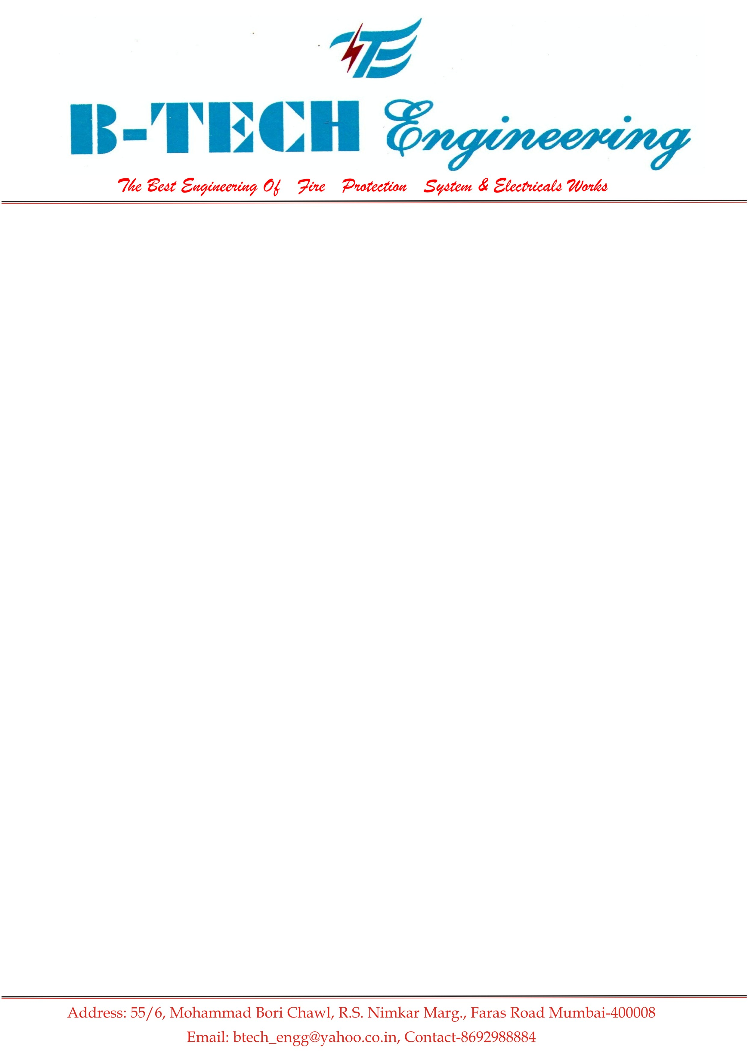

Ref No.BTE/AMSON/12/17/18 Date:02-01-2018
M/s. AMSON STEEL PVT.LTD.
Wagle Estate Thane

NON COMPREHSIVE MONTHLY MAINTENANCE CONTRACT

Maintenance agreement between:

B-TECH ENGINEERING
55/6 Mohammad Bori Chawl
R.S.Nimker Fasar Road
Mumbai 400008

1. The company agrees in consideration of Rs.75000 { IN WORDS RS : Ninety Two Thousand only }per Years to carry out the non comprehensive maintenance of the customer’s equipment as mentioned in the schedule below and keep them in good operating condition for a period of 15 Dec. 2017 to 14 Dec 2018

2. The equipment’s mentioned in the schedule is/are in operating on the date of execution of this agreement.

3. The firm agrees to make Twelve PREVENTIVE MAINTENANCE SERVICE for one year breakdown call.Whenever required

4. The Contract covers repairs to equipment mentioned in the schedule and does not cover any allied or ancillaries or connected equipment.

5. The firm undertake to make its best to carry out its obligation under the terms of this agreement as speedily as possible, but will not be responsibility for any loss, cost or expenses arising directly or indirectly from any delay in doing so.

6. Our engineer/technician shall be given full and free access to Installations to carry out the desired repairs and the customers shall also, if necessary, make its staff familiar with the working of the equipment.

- If the repair cannot be carried at customer’s location, the firm will be authorized to take to it for service center

8. The customer hereby undertake to keep the machine clean, ensuing its correct operation correctly reporting any problems relating to the machine and preventing misuse of the equipment. The equipment must be installed at a place approved by the firm representatives with proper electrical requirements and room conditions ad the site if necessary, will be changed in the presence of the firm’s representatives or with his clearance.

9. When in the firm’s opinion reconditioning and overhauling is necessary because normal repairs and parts replacement can not keep the equipment in a satisfactory condition, the firm will submit a cost estimate. Such cost if authorized by the buyer will be in addition to the charged of this agreement.

10. This agreement does not cover any work necessitated by neglect, misuse, fire or accidents and major repairs like rewinding burnt motors and transformers. Should it become necessary to carry out such work charge therefore will be extra.

11. The effect of this agreement will stand nullified in case the equipment is shifted from the original place of installation outside the premises or the right to property is transferred or the equipment is misused, dismantled, altered or service by anybody other then company’s service engineers, technicians without the consent in writing from the firm.

12. The agreement will be renewed after mentioned period with mutual consent if notice to the contrary is not given 30 days before the expiry of the period in course. The firm may terminate this agreement by giving one month prior notice in writing in which event the firm will refund to the customer pro-rata charges paid in excess of the period covered.

13. If any spares or any consumables are required for making the installations in working conditions, the same will be charged extra.

14. Any dispute arising out of this agreement shall be under the jurisdiction of Mumbai courts.

PAYMENT TERMS
- 30% Advance along with work order
- 30% Against completion of Six months of AMC period
- 40% Against completion of nine months of AMC period
(4) With GST 18% Extra

Machine /Equipment | AMC Amount (IRS) | Start of AMC | Expiry of AMC
 | 75000 | 15 Dec.  2017 | 14 Dec.  2018
  Electrical Maintenance of Hydrant System, Sprinkler Systems,,Booster system, panel Checking & Testing in Automatic & Manual Mode all power and Control wiring ,cleanig of main,star,and delta CONTACTOR KIT and panel
  Mechanical Servicing and Testing of Hydrant System, Sprinkler Systems, Booster system ,checking and greasing of pipe line ,NRV.Hydrant volve,Butterfly Valve, with all accessories

S C H E D U L E
Note: The AMC will start from the date of receipt of purchase order / payment by the customer.
In witness whereof the parties have set their signatures.

FIRM’S SIGNATURE CUSTOMER’S SIGNATURE
WITH SEAL

